

**JOMO KENYATTA UNIVERSITY OF AGRICULTURE AND TECHNOLOGY**

**SCHOOL OF ELECTRICAL, ELECTRONIC AND INFORMATION ENGINEERING**

**DEPARTMENT OF ELECTRICAL AND ELECTRONIC ENGINEERING**

**FINAL YEAR PROJECT PROPOSAL**

|  |  |
| --- | --- |
| **NAME** | **REG. NO.** |
| GACWE DANIEL NYERE | ENE212-0152/2021 |
|  |  |

**SUPERVISOR:** MR. KARANJA

**BARBERSHOP/SALON RESERVATION SYSTEM WITH A REAL**-**TIME UPDATE OF THE NUMBER OF CUSTOMERS IN THE BARBERSHOP**

*A Final Year Project Proposal submitted to the Department of Electrical and Electronic Engineering in partial fulfillment of the requirements for the award of a Bachelor of Science Degree in Electronic and Computer Engineering.*

**JULY 2021**

**DECLARATION**

This project proposal is my original work and to the best of my knowledge, has never been presented to Jomo Kenyatta University of Agriculture and Technology or any other institution for the award of a degree or diploma.

**NAME:** GACWE DANIEL NYERE **REG. NO.:** ENE212-0152/2021

**SIGNATURE………………………………………… DATE ………………………………**

**TITLE:** BARBERSHOP/SALON RESERVATION SYSTEM WITH A REAL-TIME UPDATE OF THE NUMBER OF CUSTOMERS IN THE SALON

**SUPERVISOR CONFIRMATION:**

This project proposal has been submitted to the Department of Electrical and Electronic Engineering, Jomo Kenyatta University of Agriculture and Technology, with my approval as the supervisor:

**NAME:** MR. KARANJA

**SIGNATURE………………………………………… DATE ………………………………**

**TABLE OF CONTENTS**

LIST OF FIGURES iii

LIST OF TABLES iv

ABSTRACT v

CHAPTER 1: INTRODUCTION 1

1.1. Background 1

1.2. Problem Statement 1

1.3. Problem Justification 2

1.4. Objectives 3

1.4.1. Main Objective 3

1.4.2. Specific Objectives 3

CHAPTER 2: LITERATURE REVIEW 4

2.1. Overview of Appointment Scheduling 4

2.2. Types of Appointment Scheduling 4

2.3. Current Systems 4

2.4. Proposed System 5

2.5. Software Development 5

2.5.1. Front-End 5

2.5.2. Back-End 7

2.6. Hardware Development 10

2.6.1. Microcontroller 10

2.6.2. Pressure Sensor 10

2.6.3. Arduino Ethernet Shield 11

CHAPTER 3: METHODOLOGY 12

3.1. Web Development 12

3.1.1. Planning Phase 12

3.1.2. Analysis Phase 13

3.1.3. Design Phase 15

3.1.4. Analysis and System Design 15

3.2. Mobile Application 15

3.3. Hardware Design 16

3.3.1. Customer Counter Circuit 16

3.3.2. Remote Communication 17

CHAPTER 4: EXPECTED RESULTS 18

CHAPTER 5: PROJECT TIMEPLAN 19

CHAPTER 6: BUDGET ESTIMATES 20

REFERENCES 21

**LIST OF FIGURES**

Figure 1: Sample HTML code 6

Figure 2: Basic CSS syntax 6

Figure 3: Java script sample code 7

Figure 4: XAMPP startup page 8

Figure 5: Sample PHP Database connection code 8

Figure 6: Arduino Uno Board 10

Figure 7: Force Sensitive Resistor and its pinout diagram 11

Figure 8: Arduino to Arduino Ethernet Shield Connection 11

Figure 9:Steps in software design 12

Figure 10: System Flowchart 13

Figure 11: Block Diagram 17

**LIST OF TABLES**

*Table 5.1 : Project Time-plan* 19

*Table 6.1 : Project Time-plan* 20

**ABSTRACT**

Everyone needs to go to a salon to get a haircut of their desire this includes shaving hair, grooming, and style as per the latest trends. It is impossible to predict how many individuals will be waiting to receive a service. There are a number of techniques that can be used to improve the efficiency of a salon, and one of them is to implement an online-based system. Barbershop and salon businesses are rapidly growing industries across the country. Appointment scheduling is one of the most significant actions to consider in this profession. The goal of this project is to create an internet-based barbershop/salon appointment system.

One of the most important activities to consider in this rapidly growing industry is appointment scheduling. The focus of this project is based on developing a barbershop appointment system that could be accessed via the internet. The purpose of this system is to maximize client preferences while increasing the number of customers served during usual business hours. This is a multi-objective problem aimed at introducing order in a barbershop, by saving time for both client and the barber. It will also ensure all activities within the barbershop run in an efficient manner.

Designing circuitry that counts the number of clients in the barbershop at any given time is part of the solution. The data is updated in real-time via a web application and an Android mobile app. Users will be able to register as clients or barbers on the system. When a client registers, they can select a certain barber, after which the barber's details will be displayed. After reserving the barber, one can accurately estimate the number of persons who will need to be served before their turn to avoid wasting time.

# INTRODUCTION

## **Background**

Queue management has been a concern in numerous industries for years, including finance, health care, administration, and retail. In the current technological age, it is not only necessary to manage the existing queues, but it is also important to collect statistics about the queue in order to discover trends that can be predicted. These requirements are not met in a sophisticated manner by many barbershops. Therefore, this project suggests that using a Reservation System can boost customer and barber satisfaction in a shop.

Scheduling appointments is one of the most important activities in today's high-traffic businesses. Customer satisfaction and the number of clients served can both benefit from a well-designed appointment system. This process is most often treated as a queuing system when people study appointment scheduling. The implementation of a web-based reservation program allows users to register, search for, and meet with the top service providers online.

## **Problem Statement**

Users should be able to sign up for an application and then have access to all barbershops in a specific area. At some point, everyone will need to visit a barbershop or salon to acquire their ideal hair style. A barbershop has evolved into a social gathering spot as well, but a lot of time is spent in line waiting to be served. The majority of clients are in constant evolution and are increasingly becoming cognizant of time management. Customers require a platform that allows them to log in and schedule an appointment at a nearby salon or barbershop. Barbershop and salon businesses also require a platform on which to market and demonstrate their abilities. This would be helpful to both salon customers and business owners. However, since most walk-in customers do not make an appointment, the customer should be able to know the number of people waiting in line before making an appointment. Even after making an appointment, the client requires this information.

In reality, most salon and barbershop customers do not have access to such a platform. We rely strolling into a shop or calling the barber, which is a sort of disruption. As a result, a lot of time is wasted waiting in lines that could be spent on more important activities. Implementing an online-based system is one of the strategies for increasing efficiency in a barbershop.

The proposed online barbershop/salon system not only saves the time for the customers but also saves the time of the employees. They won't have to spend as much time on the phone making appointment calls when they could be doing something more productive. Normally when the barber shop is closed, very many clients try contacting the barber to register for a future appointment. Probably they end up not reaching him/her and they both lose in one way or another. The client does not get the service and the barber loses money. Collecting data on how one’s business is doing, what hours get the most traffic, what customers get a haircut or a shave at the barbershop most often is also extremely important for planning purposes.

## **Problem Justification**

First and foremost, the barbershop system is designed to get the barbershop person more bookings. There are several reasons for this, including the fact that it keeps the business open throughout. The majority of customers prefer to book their reservations online. Barbershop appointment software not only increases bookings but also gives a leg up on barbershops that only take appointments during regular business hours. By just allowing customers to book after hours, there will be a huge boost in bookings. Barbershop appointment software streamlines many aspects of the company and includes rebooking reminders. With rebooking reminders, one can persuade clients to come in a little earlier than they might otherwise. This will lead to significant increase in repeat bookings as a result. The system to be designed has to meet the customers wherever they are. Barbershop software increases bookings through the process of adding book buttons to the website.

Barbershop appointment software shall generate more revenue for the business in a variety of other ways in addition to the increase in bookings. It shall reduce no-shows by a significant percentage.  It is well known that cancellations happen due to various reasons among them forgetting. An online booking software will automatically send customers email and text reminders 24 hours before their appointment. Good scheduling software should be designed to maximize profits. This will be achieved by allowing clients to book multiple services at once, making it very easy and convenient for barbershops to "upsell" and "cross-sell."

Barbershop appointment software helps the barber improve the customer experience in a variety of ways. For starters, online scheduling makes it easier for a company to deliver excellent customer service. Second, barbershop software can also be used as a customer relationship management system (Customer Relation Management). This allows for Viewing of Client History and provision of personalized service. Appointment software makes it possible for one to view each client’s appointment history, payment history, etc. as well as add personalized notes at each appointment such as their birthday or products they like. This enables the barber to remember the details about the clients so as to provide a personalized and memorable experience each and every time. By us of Automated Email Messages relationships between the barber and customer can be easily maintained. You can also send tailored (but still automated) messages to clients using built-in marketing tools, such as SMS messages.

Barbershop appointment software simplifies operations in a variety of ways, resulting in a more efficient barbershop. Barbershop software can be used as a point-of-sale system, allowing the barber to receive payments and issue invoices with ease. The barber can also accept pre-payments and deposits, which helps to reduce payment processing time while also lowering no-shows. The technology also syncs employee schedules with the cloud. Barbershop appointment software also manages staff schedules as well. For instance, staff can easily access their schedules from the cloud and alter their availability. The barber person gets notifications whenever customers book, reschedule, or cancel appointments. everything is stored securely in one place. Barbershop software allows the staff to store documentation securely in the cloud meaning, it can allow customers to have access to information wherever they are. Paper clutter is reduced in the process as well. Barbershop appointment software automates many aspects of the scheduling process. From the actual appointments to appointment and rebooking reminders, barbershop software frees up time and makes the business function more efficiently.

With its reporting tools, barbershop appointment software may provide a wealth of information about the barbershop. It can, for example, show the most popular services, the number of times each individual client rebooks or cancels appointments and the most loyal customers.

Appointment booking is the most straightforward technique to ensure that customers don't have to wait on the premises until it is their turn to be serviced. Customers can arrive close to their appointment time, which can significantly reduce their wait time and thus help to avoid crowding within the barbershop. As a result, one can maintain control over client flow and manage resources while reducing or even eliminating unexpected crowds. This is especially important due to the COVID pandemic prevention measures which discourage crowding.

## **Objectives**

### **Main Objective**

To design, implement and test an online barber/salon reservation system, with a real-time update of the number of customers in the shop.

### **Specific Objectives**

1. To design and implement a web application
2. To design and implement a mobile version of the application
3. To design, implement and test a device that determines client occupancy numbers in a barbershop at any given time and relays this data to the applications for remote use by potential customers
4. To establish a remote link between the application and the customer counter device

# LITERATURE REVIEW

## **Overview of Appointment Scheduling**

A variety of tools may be included in an appointment management solution. Appointments can be made in a variety of ways, including walk-ins, phone calls, and online inquiries [1]. When a customer arrives at the business or calls to set an appointment, some firms utilize a scheduling book or a simple online appointment calendar to record the appointment. This is the most common method of scheduling an appointment [2]. While online appointment scheduling is more common these days, making an appointment via phone is still available [3]. The majority of individuals prefer to book appointments online, according to a Wall Street Journal poll. The online scheduling system offers more convenience compared to other methods. [4]

## **Types of Appointment Scheduling**

Customer appointments have been scheduled for many years. For instance, doctor appointment systems have been around for quite some time now. The system was created primarily to reduce doctors' idle time since it was believed that doctors' time was more precious than patients' waiting time. However, it was later established that decreasing the patient's waiting time is just as crucial as the doctor's time. As a result, when creating an appointment system, both the business owner’s idle time and the customer’s waiting time are given equal weight. [5]

## **Current Systems**

Privately ran barbershops and salons are becoming increasingly popular in Kenya. Barbershop owners maintain their own private businesses and see customers in the evenings or at any time during the day, depending on their schedule. Some are well-known and well-liked, while others are little-known. Even if they have a good customer service delivery, new business people face a difficult scenario because they are unknown to most people. Customers, on the other hand, have a tough time identifying and selecting the best and nearest barbershop. Unscheduled appointments and long waits in the tangible form are among issues that Kenyan citizens and most customers encounter.

For starters in the business, opening a private barbershop might be difficult. For example, if a new barbershop was to start, there is currently no platform via which or from which people can learn about it. Similarly, any newcomer to a city faces some challenge of determining which barbershop is the best or closest to visit for the services. Customers have to visit the barbershop more than once to get the shop services. Most customers show up to the barbershop without making an appointment, resulting in a lengthy wait. Even after a long wait, there is a chance they will not get proper services at their convenience.

There have been studies done to try to identify and compare systems or applications that are similar to the proposed E-Barber System. Two comparative studies were conducted in order to determine the similarities and differences between these applications or systems and the system to be developed. The following are some of the systems or applications that have been chosen; Ashleys Kenya and Barber Kings Kenya. The conclusion was that the two main barbershop appointment systems in Kenya are barbershop specific, unlike the E-barber system.

## **Proposed System**

The goal is to create a platform that brings together all barbershops and customers. All barbershop owners whether they are new or have been in business for a long time can sign up for this application. People will be able to learn about and visit any barbershop of their choice in this manner. The user will be able to learn about and access the professional profiles of all registered shops from all specialties by utilizing this application. Professional experience, practicing license, educational background, barbershop timings, working days, barbershop accessibility, and other customers’ feedback are all included in the barbershop profile. Users can then schedule appointments from the comfort of their own homes.

The user can select a barbershop closest to them, one with the best professional experience, or has received positive feedback from previous customers. Without the requirement for expensive marketing, new barbershop owners can immediately join the platform and begin taking appointments. When enrolling as a customer, the user can make a deposit payment just before placing an appointment since an online payment system will be integrated. Due to walk-in customers who don't place an appointment, a counter-circuit will be used to communicate the number of customers at the shop in real-time to the appointment system. A customer can therefore tell the number of customers currently in the barbershop and the number of people who have placed an appointment.

## **Software Development**

Web development is the process of using several technologies to create a static or dynamic webpage or web application for the internet or intranet. The development of a website can be divided into two sections [6]. The first section, Front-End, consists of the web page's User Interface (UI). This is how the user will see the page. The back-end is the second section. It encompasses all databases and tables and, in essence, all server-side programming.

### **Front-End**

The front-end of a website is where the look and feel of the site are created. Various front-end development tools are used to achieve this [7]. The tools used are described below.

***HTML***

HTML stands for HyperText Markup Language, which is a programming language used to create online pages and applications. Tags represent HTML components, which are the building blocks of a website [7]. Tags do not appear on a webpage directly, but they do assist in the rendering of other material.

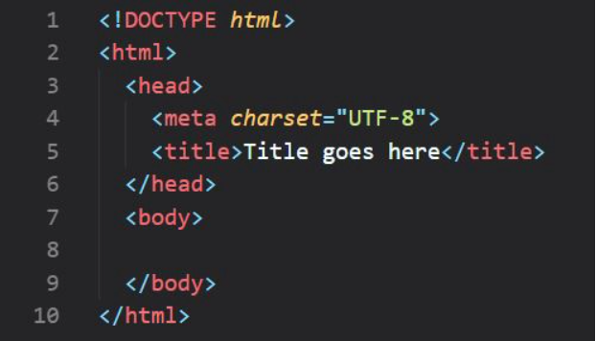

Figure 1: Sample HTML code

***CSS***

Cascading Style Sheets (CSS) is an acronym for Cascading Style Sheets. It is used to give HTML elements a style. It can be written as an HTML file or as a separate “.CSS” file. [8]

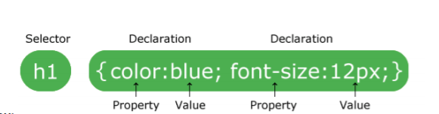

Figure 1: Basic CSS syntax

As demonstrated in the figure above, typical CSS syntax consists of a selector and a declaration block. The selector identifies the HTML element that needs to be styled. A colon separates the property and value (:). Curly braces surround each declaration block, and each declaration concludes with a semicolon (;)

***JavaScript***

JS is an interpreted high-level programming language. It is a scripting language that is mostly utilized in Web development. It does not need to be compiled because it is an interpreted language. It renders web pages in a dynamic and interactive manner. Along with HTML and CSS, it is one of the three essential technologies of the World Wide Web. [9]

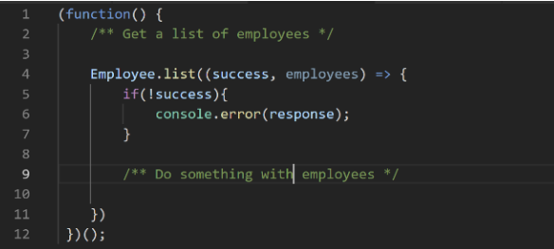

Figure 2: Java script sample code

***Bootstrap***

Bootstrap is a front-end toolkit for creating websites and online apps that is free and open-source. It comprises typography, forms, buttons, navigation, and other interface templates in HTML and CSS, as well as JavaScript extensions. Unlike many other web frameworks, it focuses solely on front-end development.

### **Back-End**

The client is regarded as a front-end and the server is considered a backend in the client-server approach; even some presentation work is done on the server [10]. Various tools utilized in a project's backend are detailed below.

***XAMPP***

XAMPP is used to represent the classification of solutions for various technologies. It provides a platform for testing applications using various technologies via a personal server. Each of the key components of XAMPP is represented by an abbreviated form of each alphabet. A web server named Apache, a database management system named MariaDB, and scripting/programming languages like PHP and Perl are all included in this collection of software. [11]

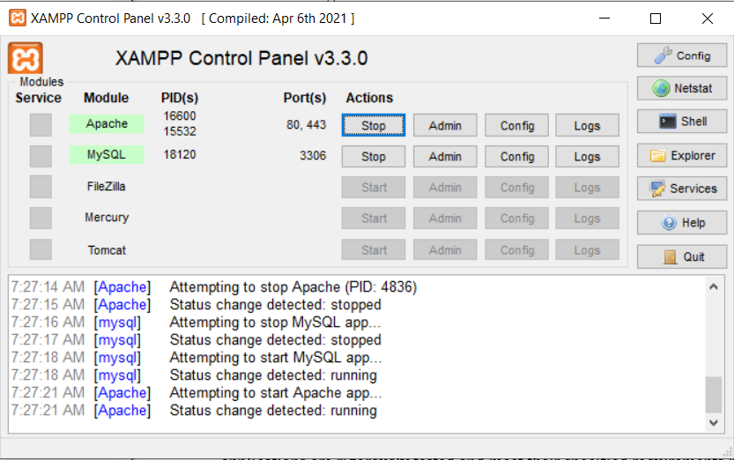

Figure 3: XAMPP startup page

***PHP***

PHP is the acronym for "Hypertext Preprocessor." It is a server-based, general-purpose open-source scripting language that is ideally suited for web development. “. PHP" is the extension for a PHP file [12]. Normal text, HTML tags, CSS styles, JavaScript scripts, and PHP codes can all be found in a PHP file. The PHP code is run on the server, and the output is sent to the browser as plain HTML.

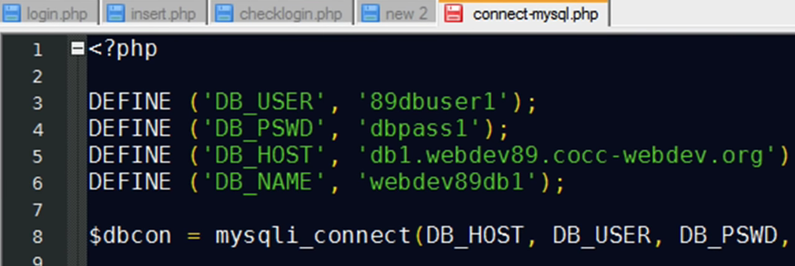

Figure 4: Sample PHP Database connection code

PHP can handle everything that happens in the backend of a website. It has the ability to generate dynamic content. It also has the ability to collect data from HTML forms and send it to databases. In a database, it can also conduct a CRUD (Create, Read, Update, and Delete) activity. PHP may be used to set admin privileges, standard user privileges, and visitor privileges.

***PHP Framework***

Laravel is a free open-source PHP web framework that is Symfony-based. Taylor Otwell was the one who came up with the idea. For web application development, it uses the MVC (model-view-controller) design. Laravel's source code is maintained on GitHub and licensed under the MIT license. [12]

***Database***

A database is a collection of data that has been arranged. The XAMPP MySQL database management system can be used to create a database and all of its associated tables. As software applications become increasingly complicated and intertwined, as well as with the rising use of enormous and diverse data from many sources, cybercrime, and a variety of other platforms, it is more critical than ever to have a durable, strong, secure, and consistent database system. Similarly, methodologies for ensuring that database-driven applications are rigorously tested and meet their specified requirements must be robust and adaptable, allowing software applications to be screened to successfully operate in any anticipated environment while maintaining the required usability and security.

A company may be prone to various risks of a system crash, internal logical structure deterioration, deletions, broken insertions, or updates. This is especially true if the software is launched without first verifying the application's database performance, security, and stability. Software testing is the process of finding software faults, isolating them, and subjecting them to correctional measures. Software testing, according to [13], is a process of informing stakeholders about the quality of a system by investigating the system under test. Through testing any of the three primary software components, namely interface codes, and database, stand a better chance of not suffering from a single defect. Due to these reasons, techniques such as black box, white box, and gray box testing were developed to test software applications via the user interface, internal logical structure, or both. Additionally, methods for specifically testing SQL database-driven applications were presented, as studying codes alone is insufficient for detecting and mitigating vulnerabilities. These methods have shown to be effective in detecting issues with software design and implementation, SQL database operations, and security issues including SQL injection and cross-origin attacks. However, they should be tweaked to detect specific vulnerabilities in programs that are database-based.

## **Hardware Development**

### **Microcontroller**

In embedded systems, a microcontroller is a small integrated circuit that governs a certain operation. On a single chip, a microcontroller contains a CPU, memory, and input/output (I/O) peripherals. These microcontrollers, also known as embedded controllers or microcontroller units (MCUs), are found in a variety of devices, including automobiles, robotics, office equipment, medical devices, mobile wireless transceivers, vending machines, and home appliances. They are essentially simple miniaturized personal computers (PCs) with no complex front-end operating system, designed to operate small characteristics of a bigger component (OS).

***Arduino***

An Arduino board is a small computer that also serves as an open-source platform for creating electronic projects. Arduino IDE is a computer-based software that runs on the physical programmable circuit board (which is the microcontroller). Before uploading computer code to the physical board, the Arduino IDE is used to generate and write it. [14]

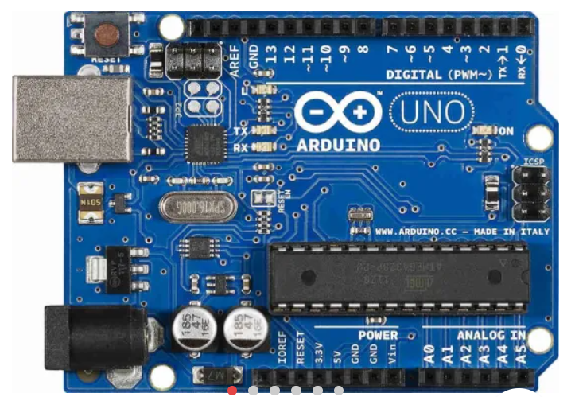

Figure 5: Arduino Uno Board

### **Pressure Sensor**

A force detecting resistor, also known as a force sensor, is a specific form of resistor that exhibits a decrease in resistance as the force applied to the active sensing surface increases. In most cases, the force detecting resistor is delivered as a polymer sheet or ink for screen printing. This sensing film has both electrically conducting and non-conducting particles. When force is applied to the sensing film's surface, the particles collide with the conducting electrodes, changing the film's resistance. [15]

There are a variety of resistive-based sensors available, but force-sensing resistors perform well in challenging settings and have a simple interface compared to other resistive-based sensors.

Despite the fact that there are many different types of force sensors, force detecting resistors have several advantages, including a small size (less than 0.5mm), low cost, and strong shock resistance. The only drawback of FSR sensors is their low precision; there will be a 10% or more variance in measurement findings. As a result, it can't be utilized as a weighing machine. It acts as a force reaction rather than a precise pressure reading.

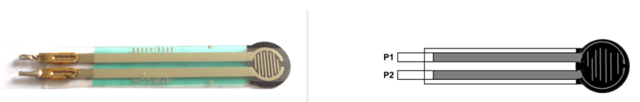

Figure 6: Force Sensitive Resistor and its pinout diagram

### **Arduino Ethernet Shield**

Using its Ethernet library, the Ethernet Shield connects an Arduino board to the internet. This Ethernet library can be used to create sketches (Arduino programs written in the IDE) that assist in configuring the shield to connect to the internet. The shield is designed to work with practically all Arduino boards. It connects the board to the internet, allowing it to receive and send data from anywhere in the world. It also has an SD card option, which can be used to write to and read from the board. This allows the project to connect to the internet opening up an infinite number of options.

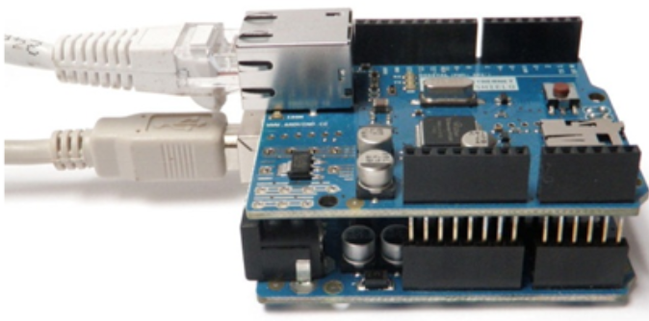

Figure 7: Arduino to Arduino Ethernet Shield Connection

Due to this connection, the Arduino board can be used for various roles; SERVER: It can function as a server, which means it can be accessed through the internet and commands can be sent from it. This server can be used in a variety of ways, such as control functionalities and to show data such as sensor readings, and much more. CLIENT: A client is a program that sends data to a server. If Arduino is operating as a client, it will be able to send data to a database on the server. This Arduino client model is used for data logging and managing massive amounts of data. [16]

# METHODOLOGY

## **Web Development**

Laravel emerges as one of the best web programming tools. For reading and writing text files, this is the best option. In comparison to other frameworks, Laravel's file processing component is based on PHP frameworks and it also performs the most effectively.

A web application built with the Laravel framework has a tiered structure. The Laravel core component extension and Framework make up the initial layer. The Laravel persistent layer of database and labels extension make up the second layer. A common data persistence structure and a batch query analysis page make up the third tier. Laravel can identify a big amount of data for business purposes. Model, View, and Controller design patterns are used in most frameworks.

The figure below demonstrates how structure developers can be used to build applications. In terms of customer interface, MVC is a program that differentiates utility/domain/commercial Page | 1 enterprises. This is accomplished by dividing MVC software into three parts: the Model, the View, and the Controller. Basic machine behavior and information are handled by the model. It responds to commands to update the status of its documents and to notify observers of periodic systems when facts change. This could be a retrieval device or a database.

In a nutshell, this is the program or software's record-keeping. View correctly implements the software's user interface feature and displays data in a form via a model that is enough for the user's interface. The controller receives the user's data request, delivers it to the model objects, and monitors the execution of relevant actions.

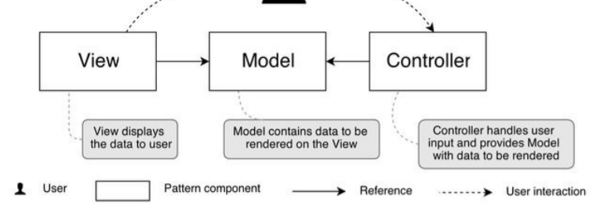

Figure 8:Web MVC Pattern

The flowchart implemented in the Ebarber system design was as follows:

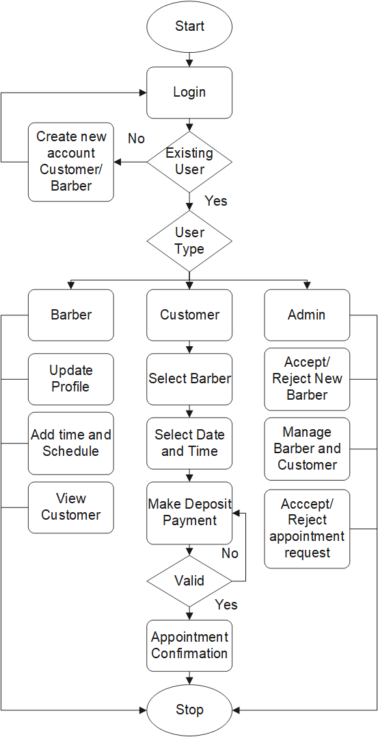

Figure 9:System Flowchart

### **Front End**

**Authentication**

Authentication is the process of determining who someone claims to be. The authentication process operates on a website, as shown in Figure below.

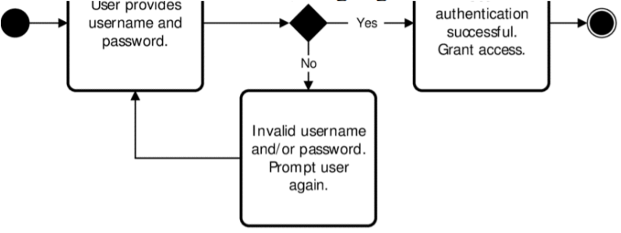

Figure 10: Web Authentication

Laravel's implementation of authentication is one of its best attributes. The configuration authentication file is located at config/auth.php, and it contains some well-documented options for modifying the behaviors of authentication services. Laravel comes with a built-in php artisan tool that can be used to construct controllers and models. Laravel comes with a number of pre-built controllers that connect the view and the model, and each controller uses a trait to store the important methods. Users can create accounts and log in to the application using the Laravel authentication layer.

Below are some of the pages designed using the superior laravel authentication tool called Jetstream:

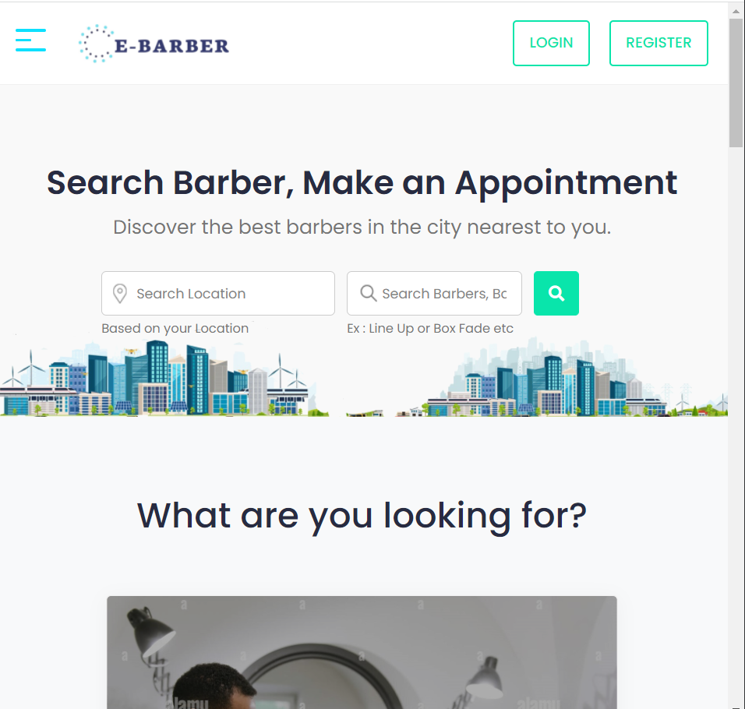

Figure 11: HomePage

The application basically has 3 usertypes; Admin, Customer and Barber. Every user is redirected to a different homepage with with similar design.

Every user has to login with the credentials the provided during the registry process.

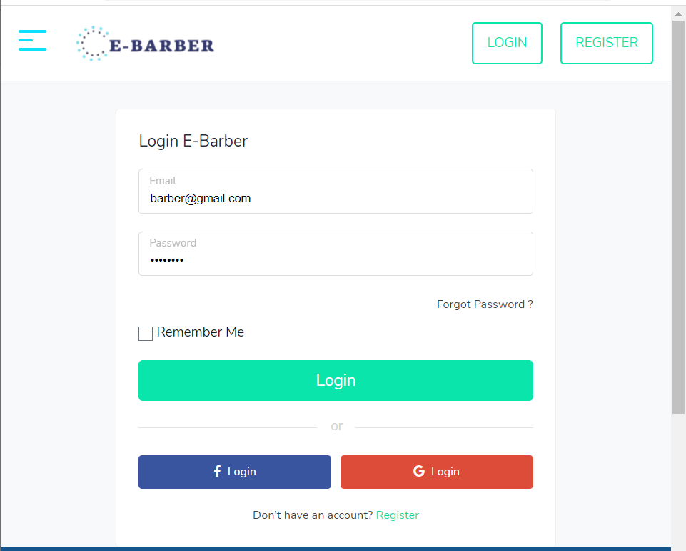

Figure 12: Login Page

The users without login credentials have to register into the system.

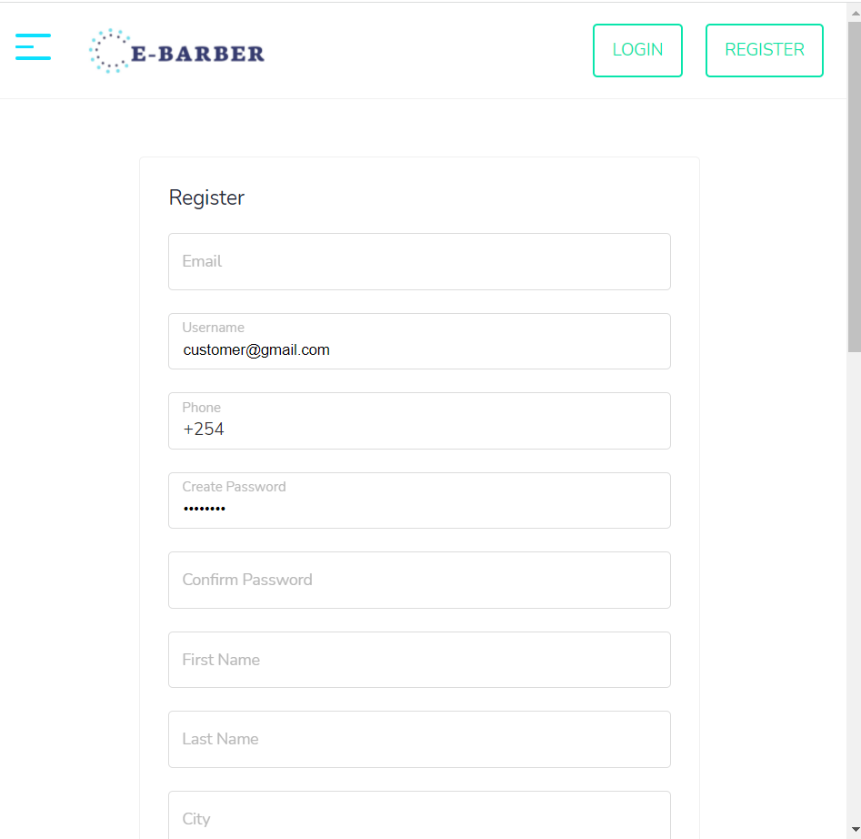

Figure 13: Register Page

There is a provision for password rest in case the user forgot their password.

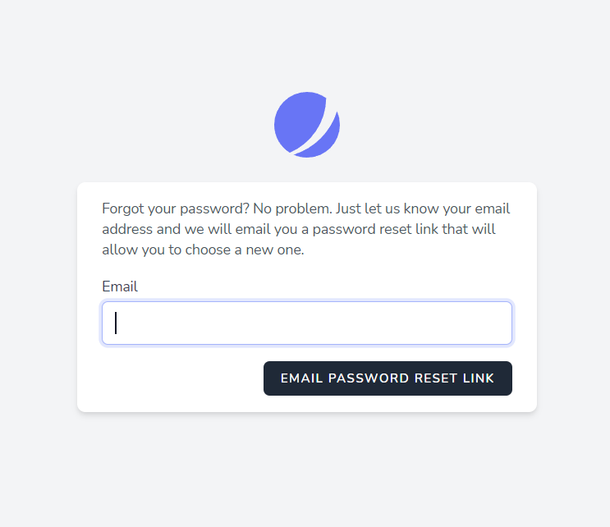

Figure 14: Forgot Password

For the customer type of users, they are provided with a platform for navigating to their barber of choice.

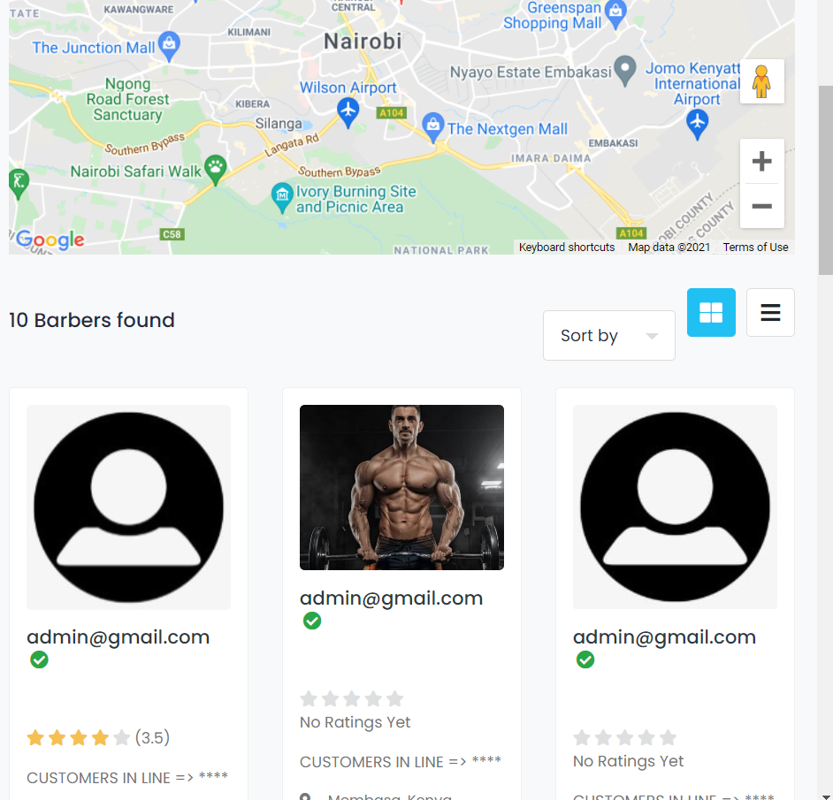

Figure 15: Search and View Barbers

Users are provided with the ability to edit their profile settings.

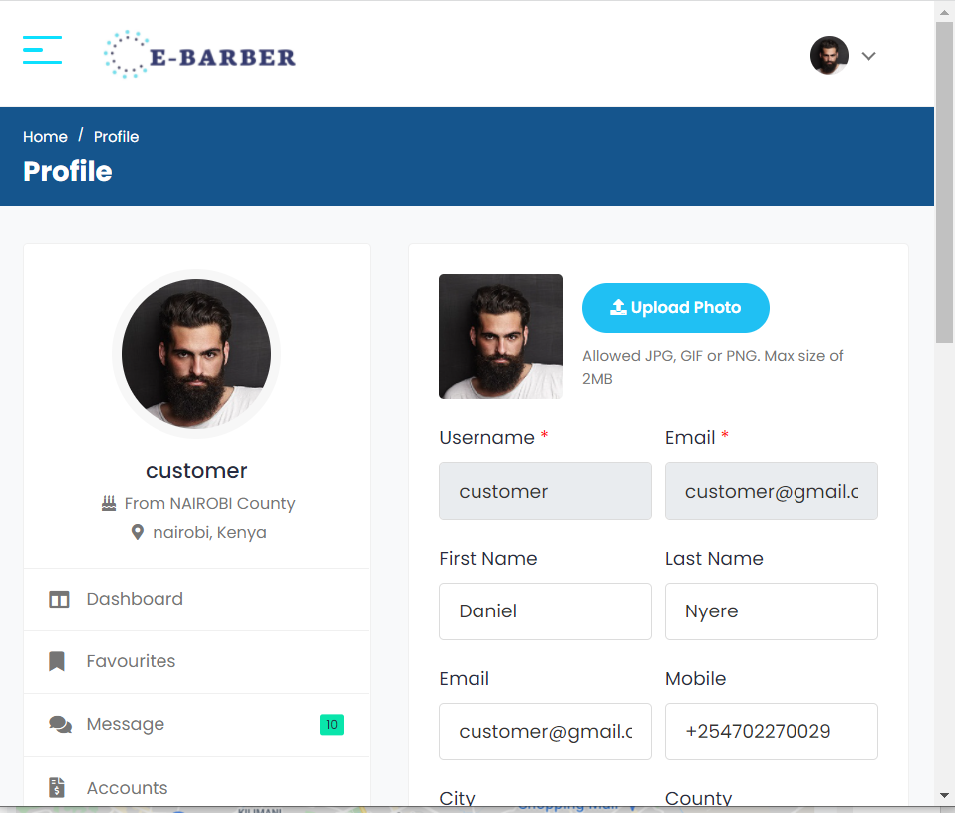

Figure 16: User Profile settings

Users are also provided with a calendar to store events and reminders if need be.

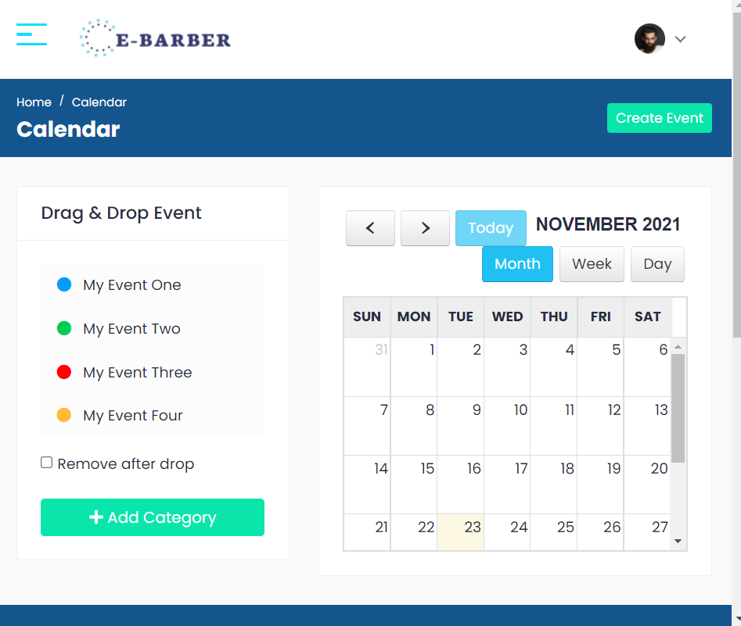

Figure 17: Calendar Functionality

Customers are provided with an interface where they can view barber ratings, reviews and pictures of the barbershop to guide them in choosing their ideal barbershop of choice.

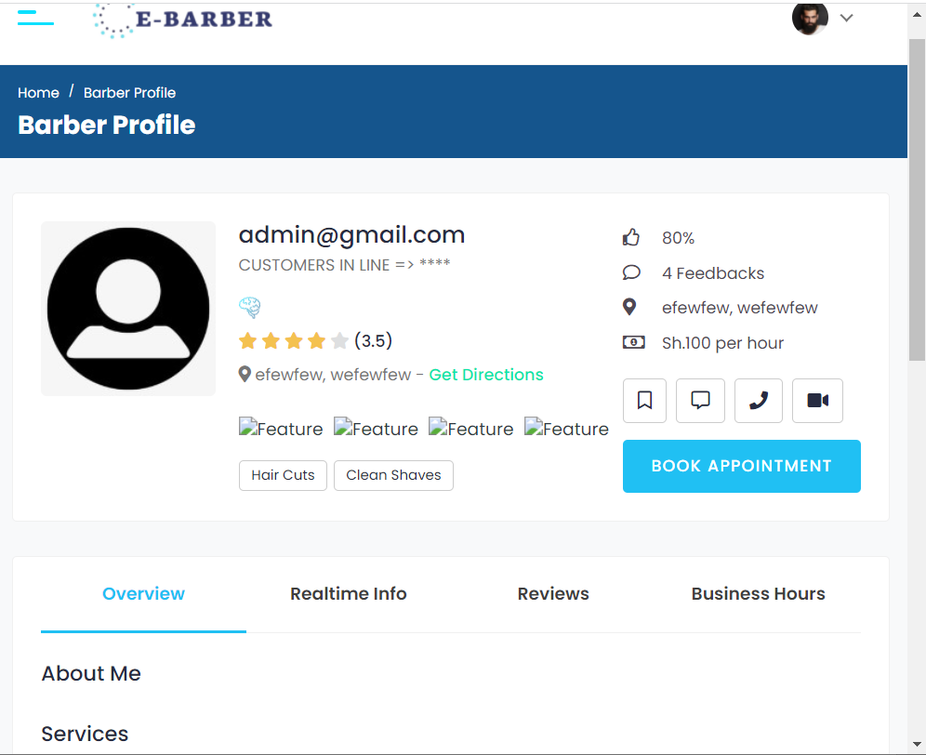

Figure 18: View Barber Details

Customers are provided with an interface where they can select date, style and timeslot for the appointment.

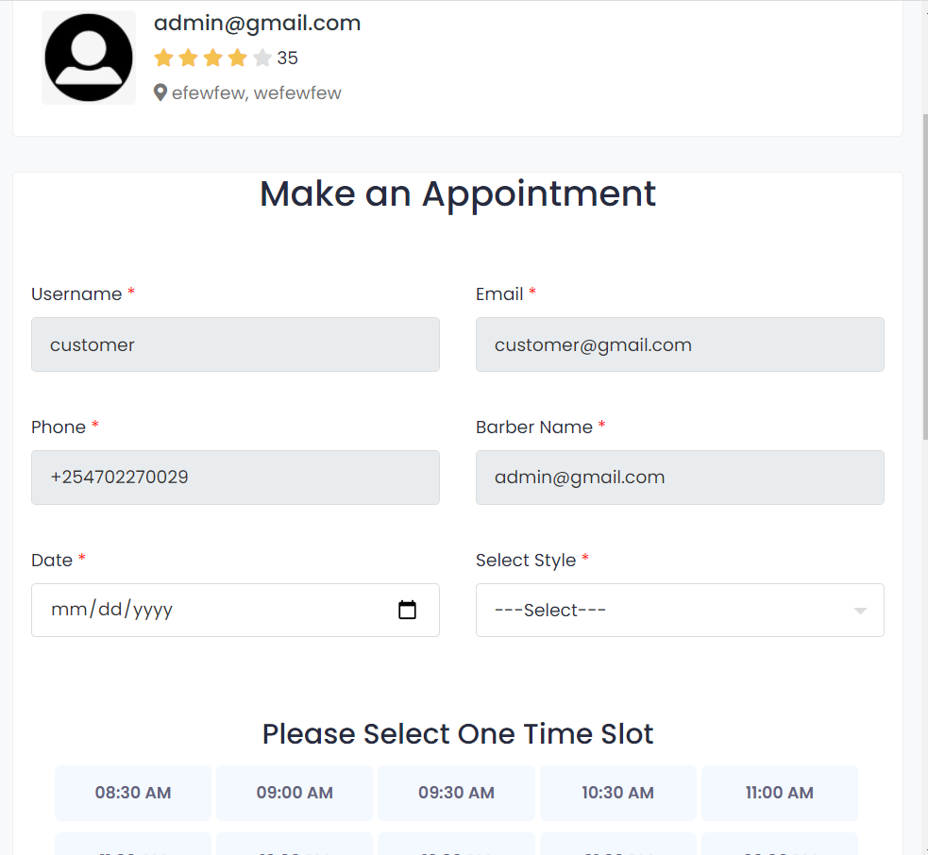

Figure 19: Customer placing appointment

There is also an interface where customers can view the occupied and vacant seats in the barbershop at any given time.

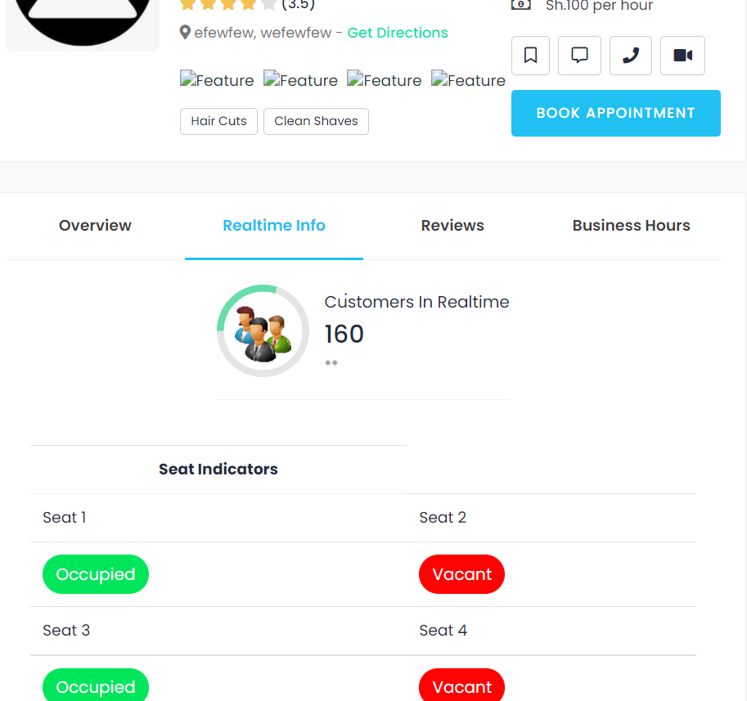

Figure 20: Real-time Customer update

Users are provided with an interface where they can make their M-Pesa transactions with a confirmation message appearing on the phone after pressing confirm and pay.

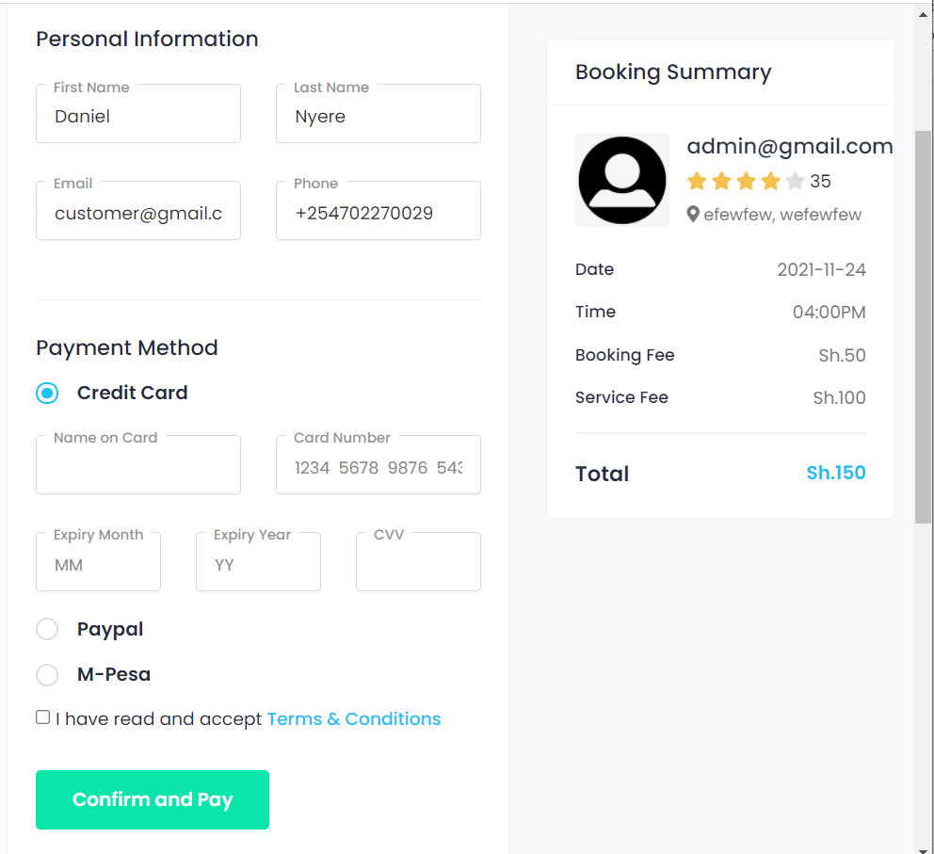

Figure 21: Payment Process

A message of success appears after successful M-Pesa transaction.



Figure 22: Successfully placed appointment

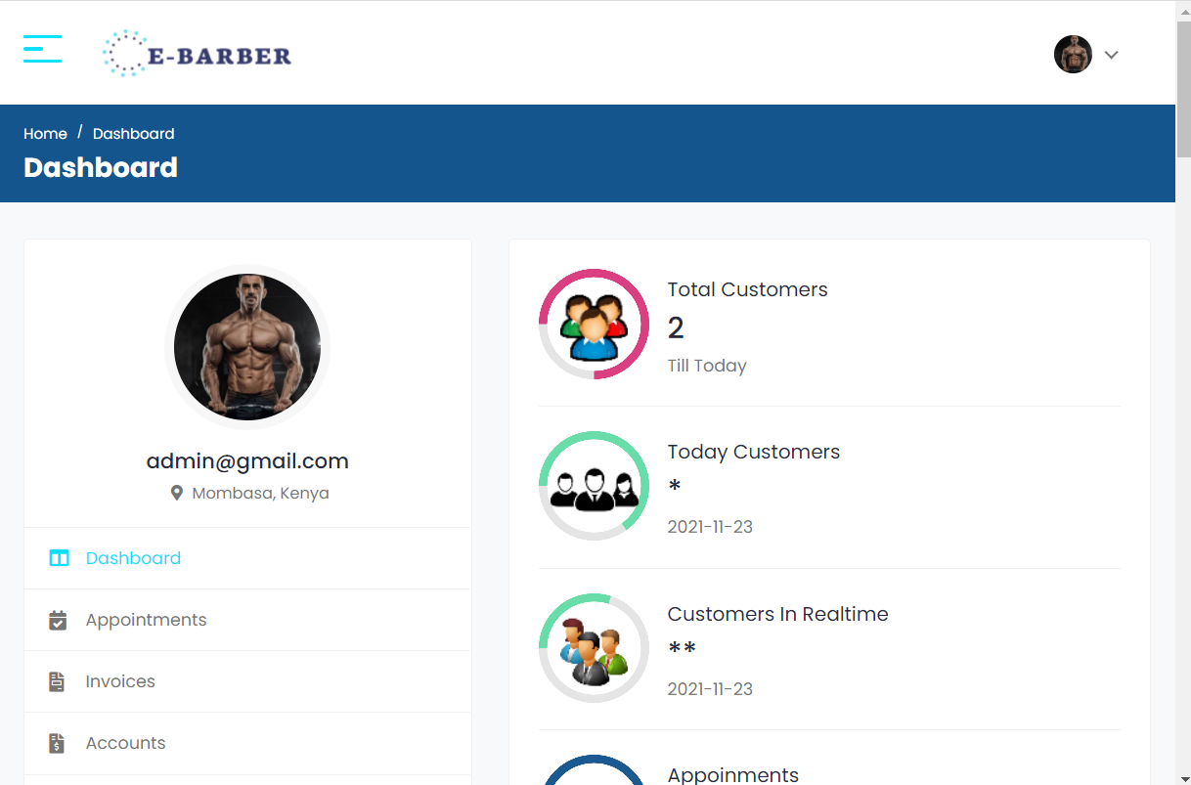

Figure 23: Barber Dashboard

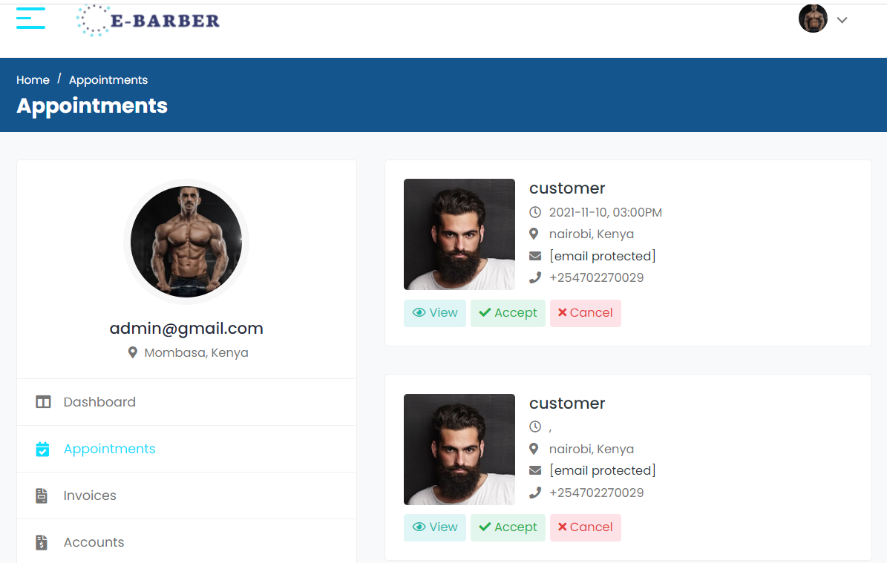

Figure 24: Barber Appointments

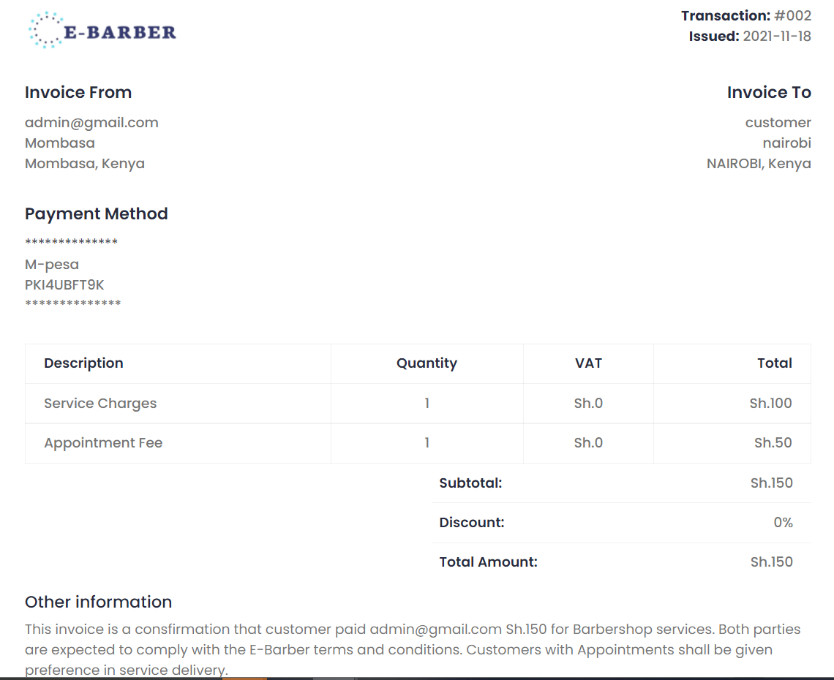

Figure 25:E-barber Payment Invoice

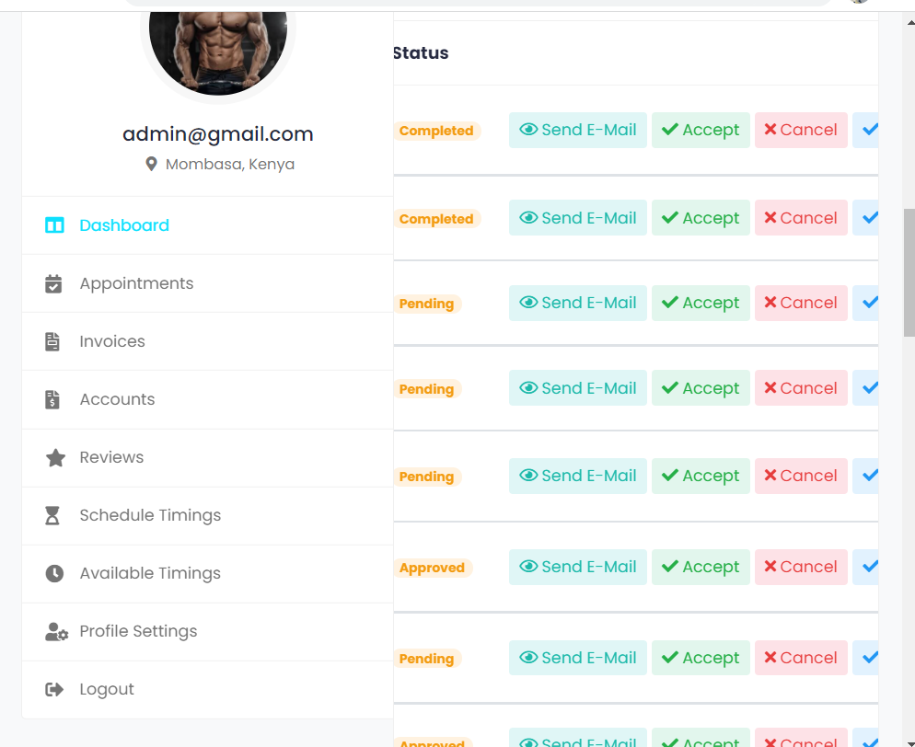

Figure 26:Barber- Customer communication

### **Back End**

Database Design:

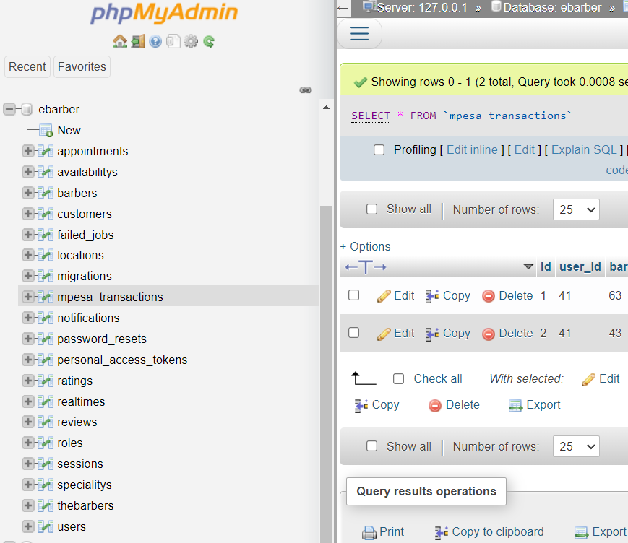

Figure 27: Php Myadmin (Mysql) using Xampp Server

### **Application Programming Interfaces (APIs)**

***Full Calendar API***

Full Calendar was used instead of the Google Calender API. It is great for scheduling appointments, events, task management and it is a simple tool to use and integrate during development.

***Lipa na M-Pesa API***

‘The Daraja API,' was used for the online payment process. It allows developers to integrate Safaricom payment for Business to Business (B2B) transactions, Customers to Business (C2B) and Business to Customers (B2C). To accept Lipa na Mpesa online, a checkout button was added on the website and app. After hitting the button, Daraja receives a post request with the appropriate payload amount. Daraja processes the request and sends a STK push notification to the user's phone, instructing him or her to enter his or her M-Pesa password and click OK to complete the transaction. M-Pesa accepts the request by debiting the user's account and transmitting the transaction data to the servers via a web-hook. The data received is the stored in the M-Pesa transaction history table, where it can be fetched by the application.

## **Mobile Application**

The website was created factoring in responsiveness to various gadgets varying from phones, tablets to laptops. It was then converted in to an android application using java. Below is the mobile view of the homepage with all other pages following the same design:

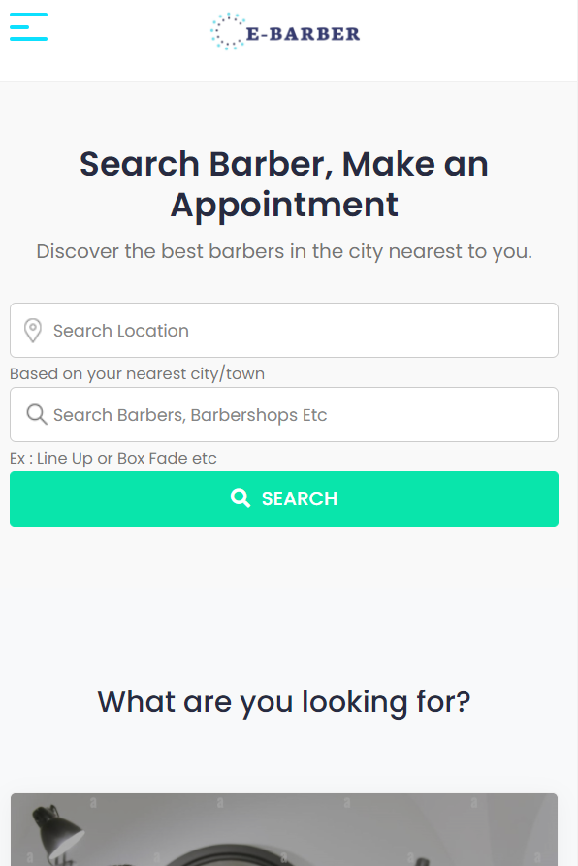

Figure 28: Home Page view with mobile phone

## **Hardware Design**

The PCB design was done by use of Easyeda where component provisions were made. The ESP32 code is attached in the appendix.

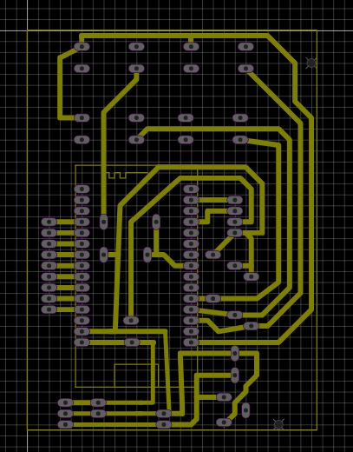

Figure 29: PCB Layout

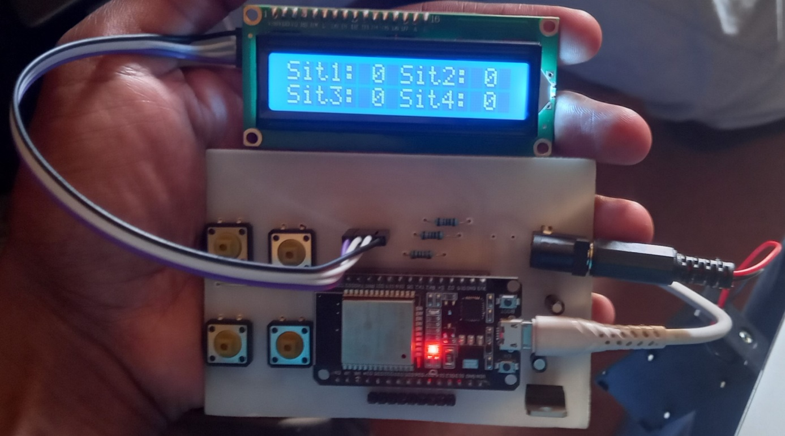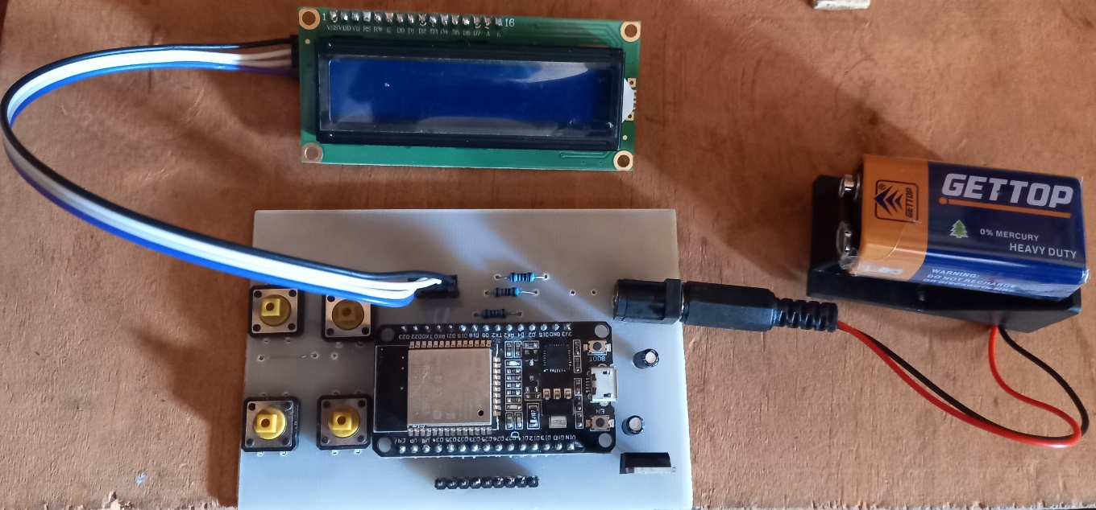

Figure 30:Hardware Components in action

Below was the proposed block diagram. However, after doing some design considerations, the Arduino microcontroller and Ethernet shield were substituted with an ESP32 module. The Force sensitive resistor was also replaced with push buttons to act as seats.

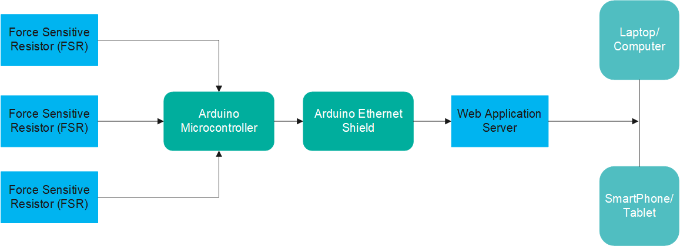

Figure 31: Block Diagram

# RESULT

The system is both useful to clients who prefer making an appointment and those that just show up without an appointment.

It is an excellent solution to the country's current challenges of time wastage in barbershops.

As stated before, there are numerous tiny barbershops all over the country. This type of system assists consumers in choosing the best barber to make an online appointment with, and it also provides all barbers an equal chance to showcase and display their skills.

Since this is Kenya’s first system of its kind, it's critical that the user interface be simple to learn and utilize. As a result, the web pages are designed in a simple user-friendly manner.

For the time being, I have decided on working on an E-barber system. However, in the future, it can be expanded to include salons and gym sessions.

# CONCLUSION

# 5.1. CHALLENGES FACED

# 1. The Arduino was initially replaced by an ESP8266 module, however due to network instabilities, ESP32 module had to adopted. Modifying the circuit to fit the new requirements was an uphill task.

# 2. Time constraint was also a challenge in that more functionalities would have been added given more time.

# 5.2. RECOMMENDATIONS

# 1. In the future, Gym and salon support systems should be added to extend efficiency in other sectors as well.

# PROJECT TIMEPLAN

|  |  |  |  |  |  |  |  |  |
| --- | --- | --- | --- | --- | --- | --- | --- | --- |
| **ACTIVITY** | **SEM 1** | | | | **SEM 2** | | | |
| **MAY** | **JUNE** | **JULY** | **AUG** | **SEPT** | **OCT** | **NOV** | **DEC** |
| DOCUMENTATION |  |  |  |  |  |  |  |  |
| RESEARCH |  |  |  |  |  |  |  |  |
| PROGRESS REPORT 1 |  |  |  |  |  |  |  |  |
| PROPOSAL WRITING |  |  |  |  |  |  |  |  |
| PROPOSAL PRESENTATION |  |  |  |  |  |  |  |  |
| DESIGN AND CODING |  |  |  |  |  |  |  |  |
| PROGRESS REPORT 2 |  |  |  |  |  |  |  |  |
| HARDWARE CONFIGURATION AND TESTING |  |  |  |  |  |  |  |  |
| PROJECT REPORT WRITING |  |  |  |  |  |  |  |  |
| PROGRESS REPORT 3 |  |  |  |  |  |  |  |  |
| FINAL PRESENTATION AND DEMONSTRATION |  |  |  |  |  |  |  |  |

# *Table 5.1 : Project Time-plan*

# BUDGET ESTIMATES

|  |  |  |  |
| --- | --- | --- | --- |
| **ITEM** | **QUANTITY** | **PRICE PER UNIT** | **TOTAL** |
| ESP32 | 1 | 1,500 | 1,500 |
| Push Buttons | 4 | 100 | 400 |
| PCB | 1 | 500 | 500 |
| Resistor | 4 | 25 | 100 |
| Resistor | 4 | 25 | 100 |
| Web Hosting | 1 | 1,500 | 1,500 |
| Battery | 1 | 50 | 50 |
| Battery Casing | 1 | 50 | 100 |
| LCD | 1 | 1000 | 1000 |
| Miscellaneous |  |  | 1,000 |
| TOTAL |  |  | 6,250 |

# *Table 6.1 : Project Time-plan*

**REFERENCES**

[1] Thangam, E. C., Mohan, M., Ganesh, J., Sukesh, C. V., & Prof, A. (2018). Internet of Things (IoT) based smart parking reservation system using raspberry-pi. *International Journal of Applied Engineering Research*, *13*(8), 5759-5765.

[2] Dantas, L. F., Fleck, J. L., Oliveira, F. L. C., & Hamacher, S. (2018). No-shows in appointment scheduling–a systematic literature review. *Health Policy*, *122*(4), 412-421.

[3] Tasseron, G., & Martens, K. (2017). Urban parking space reservation through bottom-up information provision: An agent-based analysis. *Computers, Environment and Urban Systems*, *64*, 30-41.

[4] Wang D, Muthuraman K, Morrice D. Coordinated patient appointment scheduling for a multistation healthcare network. Operations Research. 2019 May;67(3):599-618.

[5] Kong Q, Li S, Liu N, Teo CP, Yan Z. Appointment scheduling under time-dependent patient no-show behavior. Management Science. 2020 Aug;66(8):3480-500.

[6] Sarkar A. Overview of web development life cycle in software engineering. International Journal of Scientific Research in Computer Science, Engineering and Information Technology. 2018;3(6):2456-3307.

[7] Ratha AK, Sahu S, Meher P. HTML5 in web development: A new approach. International Research Journal of Engineering and Technology (IRJET). 2018 Mar;5(3):551-4.

[8] Filip P, Čegan L. Impact of HTML structure and CSS on web performance. In36th IBIMA Conference 2020. International Business Information Management Association-IBIMA.

[9] Brown E. Web development with node and express: leveraging the JavaScript stack. 2019 Nov 13.

[10] Kaluža M, Kalanj M, Vukelić B. A comparison of back-end frameworks for web application development. Zbornik veleučilišta u rijeci. 2019 May 13;7(1):317-32.

[11] Dvorski DD. Installing, configuring, and developing with Xampp. Skills Canada. 2007 Mar.

[12] Chen X, Ji Z, Fan Y, Zhan Y. Restful API architecture based on laravel framework. InJournal of Physics: Conference Series 2017 Oct 1 (Vol. 910, No. 1, p. 012016). IOP Publishing.

[13] Brdjanin D, Banjac G, Banjac D, Maric S. An experiment in model-driven conceptual database design. Software & Systems Modeling. 2019 Jun;18(3):1859-83.

[14] Badamasi YA. The working principle of an Arduino. In2014 11th international conference on electronics, computer and computation (ICECCO) 2014 Sep 29 (pp. 1-4). IEEE.

[15] Giovanelli D, Farella E. Force sensing resistor and evaluation of technology for wearable body pressure sensing. Journal of Sensors. 2016 Feb 21;2016.

[16] Nayyar A, Puri V. A review of Arduino board's, Lilypad's & Arduino shields. In2016 3rd international conference on computing for sustainable global development 2016 Mar 16 (pp. 1485). IEEE.

[17] Sabale RG, Dani AR. Comparative study of prototype model for software engineering with system development life cycle. IOSR Journal of Engineering. 2012 Jul;2(7):21-4.